**TD Bank**

**Competitive Analysis**

**Presented By**

Table of Contents

Group Contract 3

RACI Chart 5

Overview 6

Organizational Chart: 7

Mission 8

Strategy 8

Proven business model 8

Purpose-driven 8

Forward Focused 8

Vision 8

Our purpose 8

PESTEL 9

Political 9

Economical 9

Social 10

Technological 11

Environmental 11

Legal 12

Balanced Scorecard 13

SWOT Analysis 14

SWOT of RBC 14

SWOT of Scotiabank 15

SWOT of CIBC 16

SWOT of TD 17

References 18

# Group Contract

**Date: 7th September 2023**

**Insights Consulting**

**Project Team Members’ Names and Sign-off:**

|  |  |
| --- | --- |
| **Name** | **Role** |
| **Hardik Dhakan** | **Project Manager** |
| **Ashna Ashraf** | **Assistant Project Manager** |
| **Saurav Joy** | **Associate** |
| **Shashwat Bhatt** | **Associate** |
| **Aiswarya Dinesh** | **Business Analyst** |

**Code of Conduct:**

**Participation:** We will:

* Attend class sessions and meetings and work together.
* Be an active participant and contribute.
* Distribute responsibilities and duly complete respective tasks.

**Communication:** We will:

* Conduct meetings to discuss progress every two days.
* Share updates and documents on the Teams group channel.
* Listen to feedback and implement the changes.

**Problem Solving:** We will:

* Research and gather all relevant information.
* Conduct a detailed market analysis.
* Build solutions using methods such as SWOT, Balanced Scorecard, and PESTEL Analysis.

**Meeting Guidelines:** We will:

* Have fixed agendas for each meeting.
* Take notes and track progress in the group chats.
* If unavailable, team members should inform the PM or the APM beforehand.

**Academic Integrity Affirmation**

This work aligns with Conestoga’s Academic Integrity policy, and all external sources are cited and referenced as per APA guidelines.

|  |  |  |
| --- | --- | --- |
| ***Name*** | ***Signature*** | ***Date*** |
| Name 1 | Hardik Dhakan | 09/07/2023 |
| Name 2 | Ashna Ashraf | 09/07/2023 |
| Name 3 | Saurav Joy | 09/07/2023 |
| Name 4 | Shashwat Bhatt | 09/07/2023 |
| Name 5 | Aiswarya Dinesh | 09/07/2023 |

# RACI Chart

|  |  |  |  |  |
| --- | --- | --- | --- | --- |
| Task | Responsible | Accountable | Consulted | Informed |
| Market Research and Competitive Analysis | Hardik, Ashna | Hardik | Aiswarya | TD |
| Company Logo | Shashwat | Hardik | Saurav | TD |
| SWOT Analysis | Ashna, Aiswarya | Hardik |  | TD |
| PESTEL Analysis | Saurav | Hardik | Shashwat | TD |
| Balanced Scorecard | Hardik, Shashwat | Hardik |  | TD |

# Overview

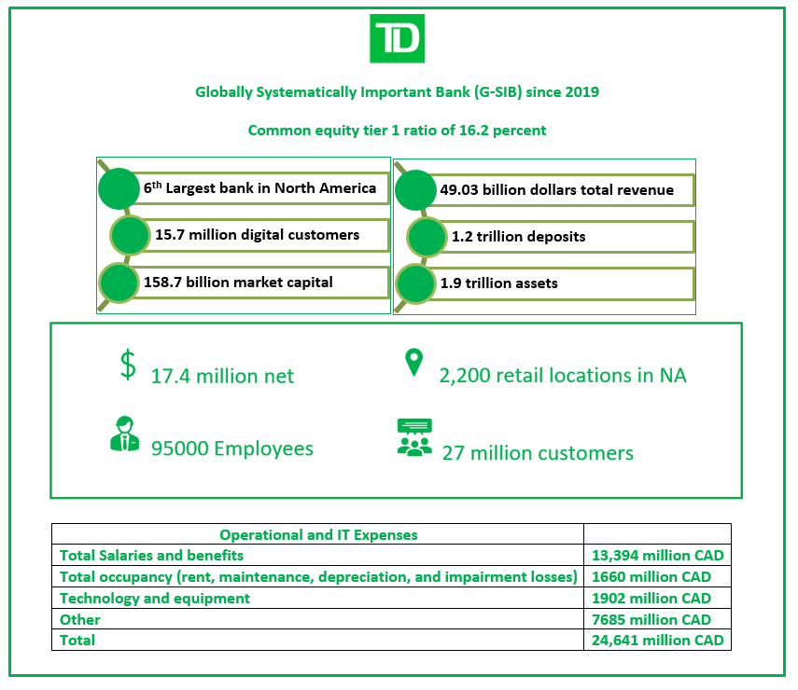

# Organizational Chart:

# Mission

## Strategy

As a top 10 North American bank, TD aims to stand out from its peers by having a differentiated brand – anchored in our proven business model, and rooted in a desire to give our customers, communities, and colleagues the confidence to thrive in a changing world.

## Proven business model

Deliver consistent earnings growth, underpinned by a strong risk culture.

## Purpose-driven

Centre everything, on vision, purpose, and shared commitments

## Forward Focused

Shape the future of banking in the digital age.

Vision

To be the better bank

Our purpose

To enrich the lives of customers, communities and colleagues.

# PESTEL

## Political

* Government Stability

Political stability is important as it has many impacts on the Bank. The government policies will be stable which can improve confidence of investors. The laws that the government establishes about issues like taxes and how much money they generate can impact the amount of money that TD Bank makes and their willingness to lend to consumers. Also, when a country is politically stable it would be having good relations with foreign countries which makes it easier for banks to do business and international trade.

* Tax Policies

Tax laws have an immediate effect on the operations and financial performance of TD Bank. Profitability and investment strategies are impacted by modifications to the corporation, dividend, and capital gains tax rates. Global operations are impacted by international tax legislation. The success of the bank depends on ongoing monitoring and adaption to changing tax laws because compliance and public perception are critical factors.

* Trade Agreements

Trade pacts and tariffs between Canada and the U.S. may have an impact on TD Bank's cross-border activities. The movement of capital, goods, and services across international borders may be impacted by changes in trade regulations, which could influence the bank's operations.

## Economical

* Inflation rates

Consumer protection regulations require compliance, disclosure, fair lending, data security, and dispute resolution, all of which have an impact on TD Bank. These rules control the bank's operations and legal obligations while preserving clients' rights and privacy. They also ensure transparency, forbid discrimination, and punish infractions.

* Foreign Exchange rate

Since TD Bank has international operations, variations in currency exchange rates could have an impact on its revenue and overall financial health. The financial health and economic strength of the bank may be significantly impacted by these swings.

* Interest rates

Changes in central bank interest rates may influence TD Bank's net interest margin as well as the rates at which the bank offers loans and accepts deposits. The financial operations of the bank are significantly impacted by these modifications.

* Market conditions

Market conditions, which include elements like loan availability and investment opportunities, have an impact on the profitability of TD Bank. The current market conditions, which include the availability of loan possibilities and potential investments, directly affect the bank's financial performance.

## Social

* Demographics

The demand for banking products and services could be affected by demographic changes, such as an ageing population or changes in customer preferences. These demographic changes may have an impact on the kinds of financial services and products that customers look for.

* Customer Diversity

With over 27 million customers, TD Bank must be aware of the shifting demands and preferences of its wide range of customers. This necessitates an acute awareness of and capacity for adaptation to changing client needs.

* Education level in the society

The activities of TD Bank are substantially impacted by the level of education in society. Better employment prospects, greater salaries, and increasing spending on sophisticated and aspirational financial goods are typical characteristics of well-educated societies, and these factors influence the bank's services and customers.

## Technological

* Digital Transformation

To remain competitive and adapt to shifting customer preferences, TD Bank must make a significant investment in digital banking and technology. This will allow it to efficiently serve the changing needs of its customers.

* Cybersecurity

According to TD Bank, the growing importance of cybersecurity plays a crucial part in protecting client data integrity and fostering trust in the world of digital banking services. This emphasises the requirement for strong security measures to guarantee a reliable and secure financial ecosystem.

* Innovative offerings

Adopting cutting-edge technologies like blockchain and artificial intelligence (AI) enables TD Bank to create creative financial offers, enhancing the range of goods and services available to its clients and encouraging an innovative culture within the organisation.

## Environmental

* Environmental Sustainability

With a focus on cutting corporate carbon emissions, promoting sustainability, and funding eco-friendly projects, TD Bank is committed to environmental sustainability. Their dedication includes taking steps to protect the environment and advance ethical behaviour. For example, use of paper can be reduced in banking operations.

* Sustainability Regulations

The dynamic environment of environmental legislation, which includes sustainable finance and green investments, has the potential to affect TD Bank's operational paradigms and investment strategies, mandating agility in response to changing sustainability standards.

* Climate change risks

The necessity of proactive risk management in a changing climatic context is shown by the way that TD Bank addresses potential risks brought on by climate change, including elements like extreme weather events and evolving legislative frameworks intended to reduce greenhouse gas emissions.

## Legal

* Data privacy laws

TD Bank is required to manage and protect client data in accordance with strict data protection laws like the GDPR in Europe. This demands adherence to international standards for data privacy and the adoption of strong data security measures.

* Employment laws

Strong employment rules exist in Canada, which are compatible with TD's business strategy. Fair labour practises, such as minimum wage requirements, workplace safety, and employee rights, are given priority under these rules. In accordance with Canadian employment rules, TD’s dedication to moral and inclusive hiring practises promotes a positive work environment.

* Consumer protection laws

Consumer protection regulations have an impact on TD Bank since they mandate that they adhere to procedures, be open and honest with customers, treat everyone equally, protect data, and handle complaints. These regulations protect consumer rights and privacy while establishing the bank's policies and legal responsibilities. They ensure openness, prohibit discrimination, and set consequences for noncompliance.

# Balanced Scorecard



# SWOT Analysis

## SWOT of RBC

One of the most well-known and regarded financial organizations in the world, the Royal Bank of Canada (RBC), is a shining example of a business that has successfully maintained the test of time and adapted to the ever-changing demands of the economy. (RBC,2022) We have identified the SWOT analysis of RBC, and it is as follows.

|  |  |
| --- | --- |
| **Strengths**     * Global presence and networks * Wide variety of products and services * Ranked as one of the top 10 banks. * Efficient automation of banking activities * Strong customer relationship * Canada’s largest bank (Royal Bank of Canada (RBC) Review 2023: What to Expect from Canada’s Largest Bank, 2023) | **Weakness**     * Branches are mainly in Canada and US * Need to invest more on fintech. * Delays in internal processes due to regulatory and compliance issues. (RBC, 2022) |
| **Opportunities**     * Invest more in financial technologies. (RBC, 2022) * Expansion of the digital transformation globally * Creation of wealth management and retirement schemes (RBC, 2022) | **Threats**     * Increasing competition in the finance and banking sector * Risk of cyber security * Tight rules and regulations * Frequent changes in the bank interest rates (Royal Bank of Canada (RBC) Review 2023: What to Expect from Canada’s Largest Bank, 2023) |

## SWOT of Scotiabank

The Bank of Nova Scotia commonly operates in the name Scotiabank is one of the Canada’s 5 biggest banks.  The major business lines include Canadian Banking, International Banking, Global Wealth Management, Global Banking and Markets (Scotiabank, 2023, Slide 6). The organization has about 90,000 employees working in different geographic locations with an employee engagement rate of Scotiabank is 87% and employee satisfaction rate of 92% (Scotiabank, 2023, Slide 19).

|  |  |
| --- | --- |
| **Strengths**     * One of the top 5 universal banks in U.S * Only bank that established full presence in all Pacific Alliance countries (Scotiabank, 2023, Slide 4-7). * 7th largest bank in America evaluating its assets in America (Scotiabank, 2023, Slide 4). * Implemented Anti-Money Laundering and cybersecurity practices. | **Weakness**     * Majority of investment and business earning are from Canada economy. * High competitiveness from Canadian banks as well as other global banks. |
| **Opportunities**     * Acceleration in Digital Banking * Launched Scotia Smart Investor which is AI powered to provide real time insights to customers (Scotiabank, 2023, Slide 7). * Advanced analytical insights and Robotic Process Automation. | **Threats**     * Inflation and slow economic growth (Scotiabank, 2023, Slide 62). * Fluctuation in policy rate. * Risk of cyber-attacks and data loss * A negative legal or political change in Canada. |

## SWOT of CIBC

The Canadian Imperial Bank of Commerce was formed from the merger of two large banks, The Canadian Bank of Commerce, and Imperial Bank of Canada on 1st of June 1961(CIBC, n.d., p. 1).

|  |  |
| --- | --- |
| **Strengths**     * Delivery of foreign cash to home, Pearson airport or CIBC Banking (CIBC, n.d., p. 1). * Available in 1,100 locations, with many of them open late and on weekends. * The major business lines of CIBC are:  1. Canadian Banking: Personal & Business Banking 2. Canadian Commercial Banking and Wealth Management 3. U.S. Commercial Banking and Wealth Management 4. Capital Markets  * Committed and works for sustainable future. | **Weakness**     * Major exposure to Canadian market. * High competitiveness from Canadian banks as well as other global banks. * Lack of fintech strategies for future enhancement. |
| **Opportunities**     * Global expansion. * Digital transformation and AI automation. * More into sustainable banking. | **Threats**     * High competition from other banks and fintech startups. * Data breaches or data loss, cyber attacks * Fluctuation in interest rate. |

## SWOT of TD

The name Toronto-Dominion Bank was created by the merger of the predecessor firms Bank of Toronto and The Dominion Bank. This Canadian financial services and worldwide banking corporation was established in 1955 and is headquartered in Toronto, Ontario. The following is the SWOT analysis of TD bank. (TD,2022)

|  |  |
| --- | --- |
| **Strengths**     * One of the financially stable banks in north America (TD,2022) * Offers various financial services. * Accessible to large customer base * Have different branches across North America (TD,2022) * Strong digital banking platforms * Reputed as the ‘best Canadian bank.’ (TD,2022) | **Weakness**     * Improper customer service * Lacking a proper global presence * Need to invest more in new technologies. * Cash flow problems (TD,2022) |
| **Opportunities**     * New customers from the digital mediums * Wealth and retirement planning services * Investing in financial technologies may attract a larger customer base. * Invest in global expansion. * Focus on ESG issues allows the bank to concentrate on sustainable financial products. (Environmental-Social-Governance-Reporting, n.d.) | **Threats**     * Increasing competition in the banking industry * Remain profitable while complying to string rules and regulations. * Currency fluctuation issues * Other competitors have advanced features and emerging technologies over their applications and websites. (Environmental-Social-Governance-Reporting, n.d.) |

# References

RBC. (n.d.). *RBC Wealth Management*.

<https://www.rbcwealthmanagement.com/en-ca/>

TD. (2022). *Annual Report 2022*

<https://www.td.com/document/PDF/ar2022/ar2022-Complete-Report.pdf>

TD. (n.d.). *Environmental-social-governance-reporting*.

<https://www.td.com/content/dam/tdcom/canada/about-td/pdf/esg/2022-esg-report.pdf>

TD. (n.d.). *About TD – TD Canada Trust*.

<https://www.td.com/ca/en/about-td>

RBC. (2018). *About RBC*

<https://www.rbc.com/about-rbc.html>

Scotiabank. (2023). *Investor Presentation*.

<https://www.scotiabank.com/content/dam/scotiabank/corporate/quarterly-reports/2023/q3/Q323_Investor_Marketing_Presentation.pdf>

Canadian Imperial Bank of Commerce. (2019). *Personal Banking.*

<https://www.cibc.com/en/personal-banking.html>

Quarterly Results Presentation. (n.d.). Retrieved September 14, 2023, from

<https://www.cibc.com/content/dam/cibc-public-assets/about-cibc/investor-relations/pdfs/quarterly-results/2023/q323presentation-en.pdf>

CIBC. (n.d.). *Sustainability*

<https://www.cibc.com/en/about-cibc/corporate-responsibility.html>

CIBC. (n.d.). History

<https://www.cibc.com/en/about-cibc/corporate-profile/history.html>

Royal Bank of Canada (RBC) Review 2023: What To Expect From Canada’s Largest Bank. (2023, July 7). *Forbes Advisor Canada.*

<https://www.forbes.com/advisor/ca/banking/royal-bank-of-canada-review/#:~:text=The%20primary%20downsides%20of%20banking>

PESTEL Analysis of TD Bank Group Building an Effective Enterprise Data Management Policy. (n.d.). *247caseanalysis*. [https://www.247caseanalysis.com/case/TD-Bank-Group-Building-an-Effective-Enterprise-Data-Management-Policy-21412-Pestel-Analysis](https://www.247caseanalysis.com/case/TD-Bank-Group-Building-an-Effective-Enterprise-Data-Management-Policy-21412-Pestel-Analysis  )

The Toronto-Dominion Bank Number of Employees 1991-2022. (n.d.). *Stock Analysis.* Retrieved September 14, 2023, from <https://stockanalysis.com/stocks/td/employees/>

TD Bank Group—Org Chart, Teams, Culture & Jobs. (n.d.). *THE ORG*. Retrieved September 14, 2023, from

<https://theorg.com/org/td-bank>